MMA 801

Introduction to Management

Submission Due Date: Friday, June 19, 2020 @ 11:59 PM (EDT)

# course deliverable – assignment #2 – 65% final grade

**Analytics Reflection/Assessment**

Please be assured that information relating to your organization, as well as your personal comments regarding the use of analytics within your organization, will be kept **strictly confidential.**

Companies have access to more data than ever before. For many organizations, capturing and using this data is changing the core focus of their business models and overall strategic decision-making process. Management of the primary activities within their value chain is coupled with the need to effectively manage across an information value chain as well. To be successful in this regard, data, and the analytics derived from it, need to be accurate, timely, adequate, and considered reliable for decision-making purposes. Equally important, this information needs to demonstrate value within the strategic and tactical decision-making process. With this in mind, prepare a reflective commentary on the extent that analytics is being used by your organization, division, or department, unit, etc. Would you describe your organization (division, department, unit) as “Analytically Challenged”, that is, struggling to use data beyond basic reporting and marketing application; as “Analytical Practitioners”, that being the use of data to address tactical and/or operational challenges; or as “Analytical Innovators”, which means successful at striving to utilize data to drive innovation within the organization, thereby developing or enhancing competitive advantages relative to competitors? To frame your discussion, think in terms of organizational culture, product life cycles and new product development, effectiveness of the organization across the informational value chain in communicating and disseminating information, a demonstrated use of analytics to assist in understanding and driving value, and a propensity to incorporate analytics into the strategic decision-making process.

To add additional value to your reflection, think in terms of the following:

1. Offer and honest, unbiased assessment of how the organization, division, department, or unit, rates and prioritizes its analytical capabilities.
2. Measure how your organization, division, department or unit, uses analytics to increase revenue in its existing markets and/or new market initiatives under way, seeks to lower costs, optimize performance efficiencies or improve decision-making.
3. Using the DELTA framework (see Appendix 1) or a similar structured framework, offer an objective scoring of your organization, division, department or unit’s capabilities relative to industry and/or sector rivals. As implied, an alternative framework focused on a similar information evaluation set, as provided by the DELTA framework, is fully acceptable.

Be sure to include specific or macro-level observations to validate the conclusions offered. As a final note, comment on two or three key things which you believe your company could initiate/undertake in order to improve its use of analytics.

|  |  |
| --- | --- |
| **Categorization\*** | **Characteristics\*** |
| Analytically-Challenged  (DELTA – Basic) | * Real or perceived data deficiency * Weak information value chain * Lack of collaboration across the organization, with respect to the dissemination of analytical data * No real driver of analytics with significant enough influence to propel the organization forward. Lacks management support. * Localized analytics focus, at best |
| Analytical Practitioners  (DELTA – Intermediate) | * Analytics are largely focused on operations and tactics. * The analytics ecosystem is fragmented…information and value is not fully communicated and disseminated across the organization. * Data exists at a “just good enough” level…the ability to truly drive competitive advantage is lacking. * Commitment is backed by resource alignment. |
| Analytical Innovators  (DELTA – Advanced) | * Data is felt to be a core component of the organization’s operations, customer service, marketing and strategy. * The organization is open to new ideas when data challenges the status quo. * The organization effectively uses analytics and disseminates it across the information value chain. * The use of analytics has resulted in a real or perceived “power shift” within the organization’s decision-making process. * Organization routinely reaps the benefits of its efforts. |

* Source: From Value to Vision: Reimaging the Possibility with Data Analytics, Kiron, Ferguson, & Prentice, MIT Sloan Management Review, SAS Institute Inc., 2013

**Alternate Assignment – Option 1**

For program participants who do not currently work for an organization, or who feel that they are not in a position to comment on the utilization of analytics within their organization, division or department, the following alternate assignment is offered.

Canadian Business magazine or similar industry periodical (Fortune, Bloomberg-Businessweek, etc.) has recently learned from several sources that you are an up and coming “business analytics expert” in Canada.

Eager to provide insight into the field of business analytics as a way to differentiate their magazine in the marketplace, and to add to its value in the eyes of managers nationwide, Canadian Business magazine (or similar periodical) has asked you to write an article for the upcoming June 2020 issue. The focus of the article is on educating its readership on the fundamentals of business analytics. The editorial team has suggested that you frame your thoughts in relation to a theme of “Using Analytics for Business Decision-Making Purposes” which the magazine plans to highlight over the next few issues. A second option to frame your discussion around would be the “Evolution of Analytics from an Information Tool to that of a Required Core Functionality” within an organization.

It is the hope of the editorial team that you will craft a creative essay which will communicate to its readers your unique perspective on the evolution and future of business analytics, complemented by well-positioned, concise examples which highlight the key takeaways which managers need to focus on.

**Alternate Assignment – Option 2**

Program participants who are currently engaged in specific or customized “analytics-based” projects within their organization may choose to use this assignment as the basis for creating a “white paper” or “project plan” relating to such a work requirement. This alternate assignment option needs to be approved by the instructor in advance.

**Non-Disclosure/Confidentiality Assurance**

Please be assured that access to assignment submissions are limited to the instructor and/or his teaching assistant (TA). All submissions are held in the strictest of confidence. Information, opinions, conclusions, and recommendations are not shared beyond this small evaluation team.

**What to Submit**

Electronic copy of your reflection/assessment in Word document (or PDF) format. Submission, via an upload to the MMA 801 Dropbox, labeled “Assignment #2 – Individual Assignment”. Submission deadline is **11:59 pm (EDT), June 19, 2020.**

Your paper is not to exceed 7 pages. Format is double-spaced, 11 pt. font. The submission is intended to demonstrate a clear and succinct thought process on your part. An “Executive Summary” is not required, however, the opening paragraph should serve as an introduction and frame the conclusion arrived at (categorization), or direction undertaken, as a result of your analysis. The use of sub-headings is encouraged as well. The inclusion of a title page, charts and/or exhibits, in an appendices format, is optional (where and if applicable), and are in addition to the 7 page maximum noted above. External information sources, if used, should be noted in an “End Note” format, at the back of the analysis. Direct quotes should identify source identification via “Footnote” references.

**Appendix 1 - DELTA Framework**

Developed by Thomas Davenport and Jeanne Harris, and communicated in their book “Competing on Analytics, the DELTA Framework provides a tool which offers a focused assessment of your organization, division or department’s analytical competencies across five critical metrics…Data, Enterprise, Leadership, Targets, Analysts. Using a scale of 1 to 6 on each of these metrics, an average weighting is then derived, thereby offering a macro-level assessment, which can be compared to medium scores across an industry as well as industry-best players.

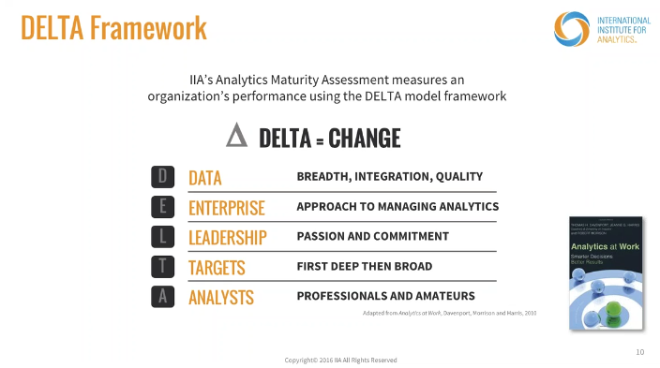

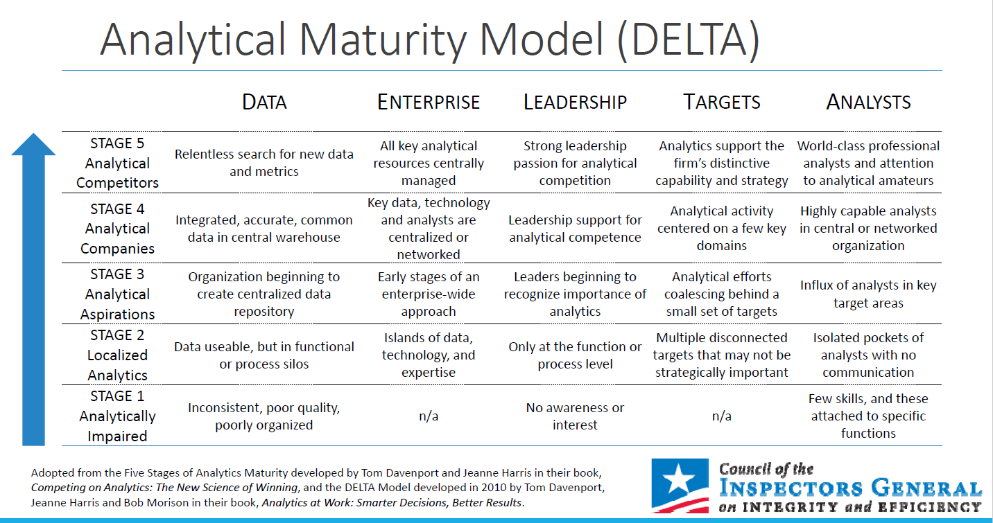

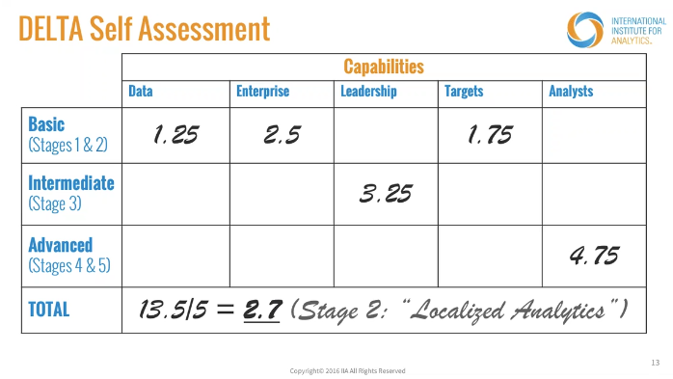

Weighted Average Score

Basic – 1.0 to 2.99

Intermediate – 3.0 to 3.99

Advanced – 4.0 to 5.99